IMPACT Conference is now Calling For Papers till June. 15th!!
A global platform with integral outstanding expertise in packaging and PCB professionals
IMPACT 2017 Conference, which is organized by IEEE CPMT-Taipei, iMAPS-Taiwan, ITRI and TPCA, is the largest gathering of packaging and PCB professionals in Taiwan. For grasping the latest trend, the IMPACT highlights the theme “IMPACT on Intelligent Everything” toward intelligent innovations, which fall into several areas: smart application, robot, drones, autonomous vehicles, artificial intelligence and IoT devices.
IMPACT is more than happy to welcome all the industrial experts and researchers to submit their papers!! The conference collects numbers of papers from 18 different countries and record more than 200 speeches every year. On the other hand, for enterprises which are looking for enhancing company identity and technological strength, IMPACT welcomes for corporative sponsorship.

This year, it is our pleasure to have John Chen from Nvidia sharing his insights of the Intelligent Things ranging from A.I./Deep learning, Self-driving cars, VR/AR…etc., and how these killer apps demand and affect the electronics industry from foundry, to packaging to system integration. Moreover, VP Shreekant (Ticky) Thakkar from HP will enlighten the Ambient Computing, and how it’s woven into the fabric of everyday life, and address opportunities and challenges that we must overcome. Besides, our honorable committees are coming from high-tech industries, like TSMC, Intel, IBM, Toshiba, Dow chemical, Atotech, ASE, Unimicron, …etc, academic circles from HK, EU, USA, KR, JP…etc, and global research institutes from KR, JP, USA…etc. With regard to the special forum, topics of Fan-out, memory, IoT,emerging and embedded technology are going to be presented by experts. Furthermore, two special forums will be held by ICEP from Japan and iNEMI from U.S.A., we look forward to exploring their professionals with you!

IMPACT will also be held in conjunction with TPCA SHOW 2017 at the same period, the valuable influence toward future trends that will shape the platform of high-tech industry and academic research is going to be built in this grand international conference. Therefore, the influence of IMPACT cannot be ignored! Arranging your schedule for IMPACT symposium and TPCA show this October !

【Date】Oct 25th to Oct. 27th , 2017
【Venue】Taipei Nangang Exhibition Center
【Theme】IMPACT on Intelligent Everything
【Exhibition】TPCA Show 2017
【On-line Submission】http://www.impact.org.tw/
【Important Date】
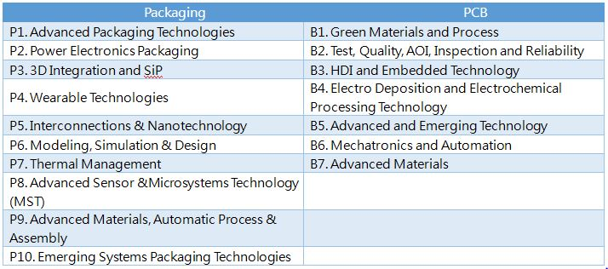
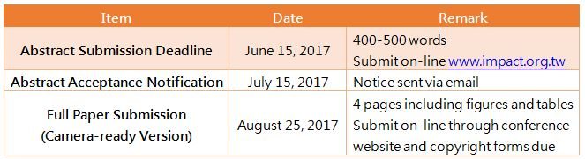
【Scope of Paper Solicited】

Visit IMPACT Website by scanning QR code!

【Contact us】
Taiwan Printed Circuit Association (TPCA)
(O): +886 3 381 5659 #405- Miss Cho (Kristy)
(Fax): +886 3 381 5150
E-Mail: service@impact.org.tw
發稿單位 | 台灣電路板協會 | 發稿日期 | 2017. 5. 22
新聞聯絡人 | 呂振吉 T:03-3815659 #402 Email: vamps@tpca.org.tw
大會秘書處 | 卓美彤 T:03-3815659 #405 Email: service@impact.org.tw

